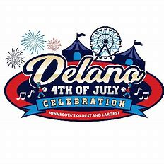
2022 Vintage Clothing/Flea Market Event
Vendor Registration Form
Sunday July 3^{RD,} 2022
12 p.m. – 5 p.m.
Vendor Name: __________________________
Contact info: ___________________________
Type Of Items Selling: ____________________
_______________________________________
All vendors are responsible for bringing tables, tents & chairs
No electricity will be provided
Set up and check in will be from 11 a.m. to 12 p.m.
$80 fee required, payments must be received by July 1st, 2022
Make checks payable to: Delano 4th of July Committee
203 Bridge Ave. East Suite 220 - Delano, MN 55328

